

BUTLER

COWLEY

SUMNER

SEDGWICK

Guidelines for 4-H Day

REVISED AND UPDATED - JANUARY 2024



County Responsibilities......................................................2

Objective.............................................................................2

General Information............................................................3

4-H Day Event Guidelines..................................................4

Public Presentations...........................................................5

Demonstration and Illustrated Talk Scoresheet……...........6

Project Talk Scoresheet......................................................7

Public Speaking Scoresheet...............................................8

Readings Scoresheet.........................................................9

Table of Contents

1



County responsibilities will be determined annually based on changes in location or involvement. All counties are expect to assist in whatever capacity they have within reason.

**Host** Sedgwick County (may vary year to year)

**Location** Sedgwick County Extension Office

**Ribbons** Sedgwick County

**Treasurer** Sedgwick County

**Judges’ Packet** Cowley County

**Expenses** Split equally amongst participating counties

**Equipment** Provided by county hosting. Supplemental supplies may be requested by host.

**Labor** Will by jointly supplied by all counties. Each is expected to supply between 2-4 volunteers excluding themselves.

County Responsibilities

Objective

1. To demonstrate the values of the 4-H Youth Development Program through public presentation and evaluation of:
   1. Demonstrations and Illustrated Talks
   2. Project Talks
   3. Public Speaking
2. To provide an opportunity for fellowship and wider acquaintance among 4-H members.
3. To exchange information regarding Citizenship, Healthy Living and Science.
4. To present a favorable image to the public and promote 4-H.

2

General Information

Age is determined by the age of 4-H members on January 1 of the current 4-H year.

Clover Buds - 5-6 years

Junior Division - 7-9 years

Intermediate Division - 10-13 years

Senior Division - 14 and over

*Age of the oldest participant in a duo or group will determine the age of the group.

Example: If one youth is 11 years old and the other is 14, they group will participate in the Senior Division.

**Clover Buds may NOT participate at Regional 4-H Day.

Entries will be placed into one of the following ribbon grouping categories based on the Danish Ribbon Grouping System: Top Purple, Blue, Blue, Red or White. If quality merits, the top three ribbon placings will be named for each age category and type of presentation. Top three ribbon placings will qualify for entry into Regional 4-H Day.

Rolling Carts will be provided in demonstration areas at Regional 4-H Day to facilitate the ease of set up.

If participants use powerpoint or other technology, an LCD projector will be provided. It is the member’s responsibility to bring all other necessary equipment and connections.

In all areas, members should clear their props, materials, equipment from the performance area *before* visiting with the judge. This will help us keep on schedule and is a courtesy of performing.

Please follow copyright laws when participating in 4-H Day. Use of brand names and trademarks is discouraged.

Participants should dress appropriately. This should be considered a dress-up event.

Results will be announced at the completion of each division.

Please note that counties are not required to offer every category at the local level. Categories which may or may not be offered on a local level.

Please note that the Regional Club Day event may not offer every event that is offered at the local level. Projects offered at the Regional Club Day may also fluctuate year to year at planning committee’s discretion.

3

| SECTION | EVENT | **REGIONAL**  QUALIFICATION/NUMBER OF TOP RIBBON PLACINGS FOR COUNTY & REGIONALS | NUMBER OF 4-H PARTICIPANTS | MAXIMUM TIME ALLOWED |
| --- | --- | --- | --- | --- |
| **PUBLIC PRESENTATIONS** | Speech  Sr. Public Speaking  Sr. Impromptu Public Speaking  Jr. and Int. Project Talks | 3  3  3 | 1-2  1-2  1-2 | 8 minutes  8 minutes  5 minutes |
|  | Demonstration/Illustrated Talk  Senior  Intermediate  Junior | 3  3  3 | 1-3  1-3  1-3 | 8 minutes  8 minutes  5 minutes |
|  | Reading  Senior  Intermediate  Junior | 3  3  3 | 1  1  1 | 5 minutes  5 minutes  5 minutes |

4-H Day Event Guidelines

4

5

**Public Speaking**

Public Speaking is intended to assist Senior 4-H members further develop confidence and skill in speaking before an audience. Talks are original and topic may be any of interest to 4-H'er. Visuals may be used. One or two notecards are suggested. Maximum time for presentation is 8 minutes. Outlines are required for the judge. Failure to provide an outline will result in the dropping of 1 ribbon placing.

**Impromptu Presentations**

Impromptu is intended to assist Senior 4-H members further develop confidence and skill in organizing thoughts and speaking before an audience. Participants will draw for a topic and are given 7 minutes to prepare. Topics will be of a general nature and notecards will be provided. No study or research material is allowed in the prep room. Maximum time for presentation is 8 minutes.

**Project Talk**

Project Talks are intended for younger 4-H’ers (Juniors and Intermediates) to gain confidence in expressing themselves before an audience. They may tell of their actual project experiences with the purpose to inform the audience. Visuals may be used. Maximum time limit is 5 minutes.

**Demonstrations and Illustrated Talks**

Demonstrations involve making or doing something while giving an explanation. It uses actual items, supplies, equipment, people or animals while going through a process. There is usually a finished product to show. Juniors and Intermediates are limited to 8 minutes for their presentation. Seniors are limited to 8 minutes. Each participant has 3 minutes to set up and 2 minutes to tear down. *Please clear your table before conferencing with the judge to allow the next presenter to set up their demonstration.*

Illustrated Talks tell how something is done. Pictures, charts, models, equipment and other types of visual aids. The purpose is to inform the audience. Juniors and Intermediates are limited to 8 minutes for their presentation. Seniors are limited to 8 minutes. Each participant has 3 minutes to set up and 2 minutes to tear down. *Please clear your table before conferencing with the judge to allow the next presenter to set up their demonstration.*

Public Presentations

5

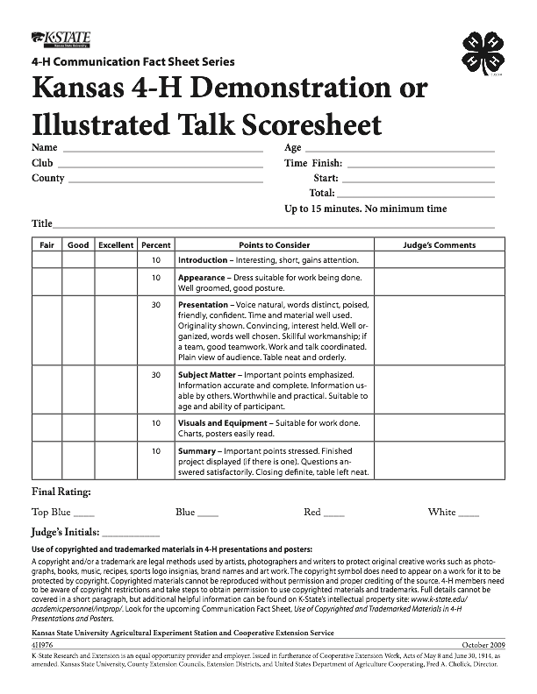

6

8

10

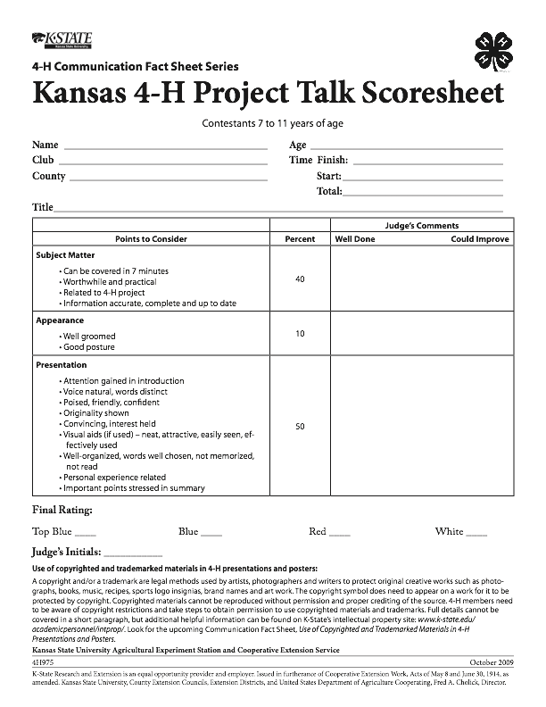

7

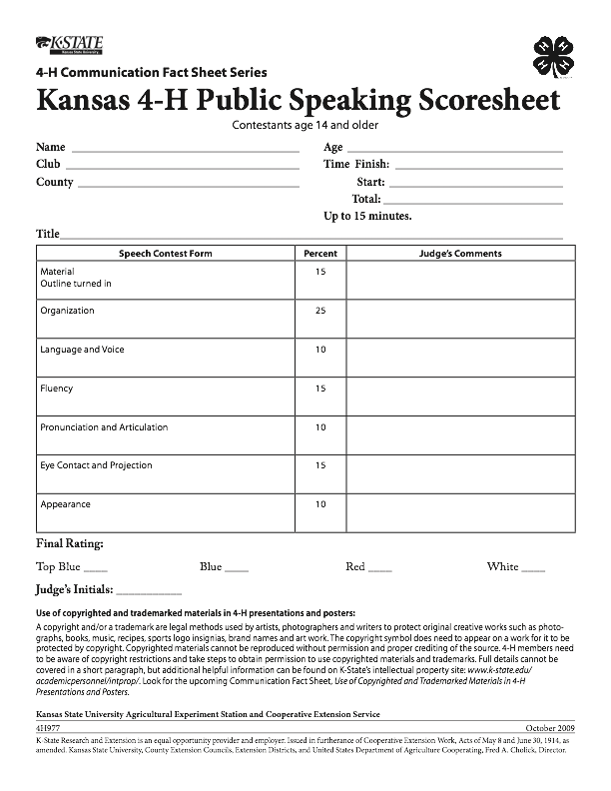

8

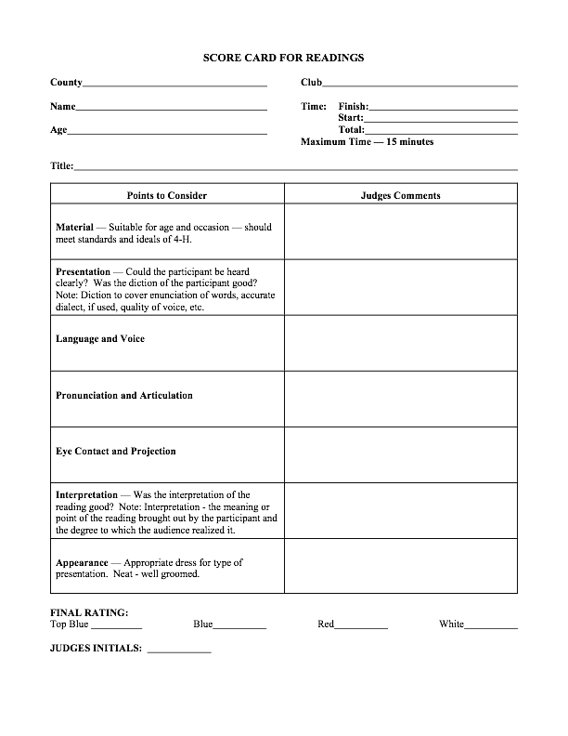

9